**Exp.1** **Design an LED flasher**

Circuit Diagram:

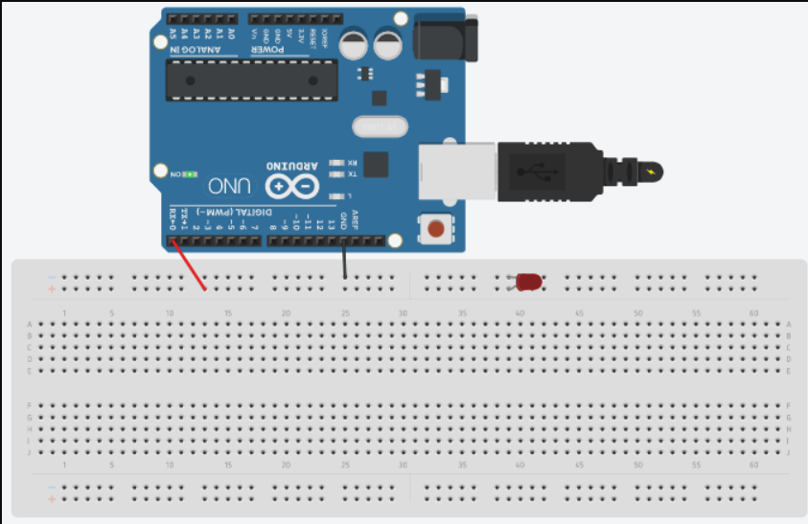

Theory

Concepts required

1. Working of ARDUINO UNO
2. Coding in ARDUINO IDE and syntax of the same
3. Procedure of LED working
4. Connection making of breadboard.

LEARNING & OBSERVATIONS

Working with ARDUINO UNO was a great experience. It teaches the deeper concepts about circuit building. Coding in IDE is very similar to coding in c. Delay function was a new thing learnt by me. ARDUINO seems to be a first step towards creating something big in hardware world

PROBLEMS AND TROUBLESHOOTING

There were not a lot of problems faced by me during this first exp ,felt really interesting watching the functioning of ARDUINO board

Looking forward to creating something new with ARDUINO

PRECAUTIONS

1. Remember to declare the codes correctly for digital input and output
2. Remember to connect negative of device to GND in ARDUINO UNO to ensure potentia

LEARNING OUTCOMES

Skills about using ARDUINO and doing coding on it, how to further use ARDUINO board in other scenarios.